In-depth exploration of Machine Learning Approaches for Fake News Detection

Srinivasan A  
*Department of Computer Technology*  
*Madras Institute of Technology-Campus, Anna University*Chennai, India  
2019503576@annauniv.edu

Pramoth G  
*Department of Computer Technology*  
*Madras Institute of Technology-Campus, Anna University*Chennai, India  
2019503574@annauniv.edu

***Abstract*—The rise of fake news has led to widespread concern and increased interest in developing effective methods for detecting such content. In this research paper, we present an approach for detecting fake news using a combination of machine learning techniques and natural language processing. We use a dataset of news articles from various sources labeled as either fake or real to train and evaluate our models. Our approach involves extracting relevant features from the text of the articles, such as the presence of certain words and phrases, and using these features as input to machine learning classifiers. We compare the performance of several different classifiers, including logistic regression, decision trees, and random forests. LSTMs with different embeddings are also developed and compared. Different data visualization techniques are compared to obtain and provide the best possible summary of the dataset. The objective is to compare as many Feature Engineering, Classifiers, Ensemble models and Neural Networks (LSTMs) as possible to find an approach that is the most effective at detecting fake news. We also intend to provide a detailed analysis of the features that are most important for accurate classification, and discuss the implications of our findings for future research in this area. Overall, our approach demonstrates the potential for using machine learning and natural language processing to combat the spread of fake news.**

***Keywords—Fake news Detection, Natural Language Processing, Comparative Analysis, Text classification, Information credibility***

# Introduction

## Social Media and Fake News

Social media includes websites and programs that are devoted to forums, social websites, microblogging, social bookmarking and wikis. On the other hand, some researchers consider the fake news as a result of accidental issues such as educational shock or unwitting actions like what happened in the Nepal Earthquake case. In 2020, there was widespread fake news concerning health that had exposed global health at risk. The WHO released a warning during early February 2020 that the COVID-19 outbreak has caused massive ‘infodemic’, or a spurt of real and fake news—which included lots of misinformation.

## Natural Language Processing (NLP)

Natural Language Processing (NLP) and Sentiment Analysis are powerful tools that can be used to detect and combat fake news. NLP involves the use of algorithms and statistical models to analyze and understand human language, while Sentiment Analysis focuses on identifying the emotional tone and subjective opinions expressed in a text. In the context of fake news detection, NLP and Sentiment Analysis can be used to analyze the language used in news articles, and identify patterns that are indicative of fake news.

NLP and Sentiment Analysis provide powerful tools for detecting and combating fake news. By analyzing the language and structure of news articles, these techniques can identify patterns that are indicative of fake news and help to prevent the spread of misinformation.

## Data Mining

Data mining techniques are categorized into two main methods, which is; supervised and unsupervised. The supervised method utilizes the training information in order to foresee the hidden activities. Unsupervised Data Mining is a try to recognize hidden data models provided without providing training data for example, pairs of input labels and categories. A model example for unsupervised data mining is aggregate mines and a syndicate base

## Machine Learning (ML) Classification

Machine Learning (ML) is a class of algorithms that help software systems achieve more accurate results without having to reprogram them directly. Data scientists characterize changes or characteristics that the model needs to analyze and utilize to develop predictions. When the training is completed, the algorithm splits the learned levels into new data. There are eight algorithms that are adopted in this paper for classifying the fake news.

# Problem Statement

The rapid spread of fake news has become a major concern in recent years, with the potential to cause significant harm to individuals, institutions, and society as a whole. Fake news can be used to spread false information, manipulate public opinion, and undermine trust in established institutions. While there have been efforts to combat the spread of fake news, the development of effective techniques for detecting and identifying fake news remains a significant challenge.

Therefore, the problem statement for this research paper is to investigate and develop effective methods for detecting fake news. This includes exploring the use of various machine learning and natural language processing techniques to analyze the content and structure of news articles and identify patterns that are indicative of fake news. Additionally, this research will investigate the limitations and challenges of current approaches to fake news detection, and explore strategies for improving the accuracy and effectiveness of these methods. Ultimately, the goal of this research is to contribute to the development of a comprehensive and effective approach to combating the spread of fake news.

# Objectives

1. To preprocess the raw data and extract relevant features from news articles, including the use of natural language processing techniques such as tokenization, stemming, and stop word removal.
2. To develop a binary classification model using machine learning algorithms, such as logistic regression, decision trees, and random forests, to distinguish between fake and real news articles.
3. To evaluate the performance of the binary classification model using various metrics, such as accuracy, precision, recall, F1-score, and confusion matrix.
4. To conduct a comparative analysis of the performance of the different machine learning algorithms used and identify the most effective model for fake news detection.
5. To investigate the impact of different feature sets on the performance of the model, including the use of headline and body text features, as well as other features such as the length of the article, the number of named entities, and the presence of certain keywords.
6. To explore the impact of various hyperparameters on the performance of the model, such as the number of trees in a random forest model, or the regularization strength in a logistic regression model.
7. To provide insights and recommendations for improving the effectiveness of the model and the accuracy of fake news detection, including suggestions for future research directions in this field.
8. Develop LSTM models with different embeddings and compare their effectiveness.

# Software Architecture Diagram

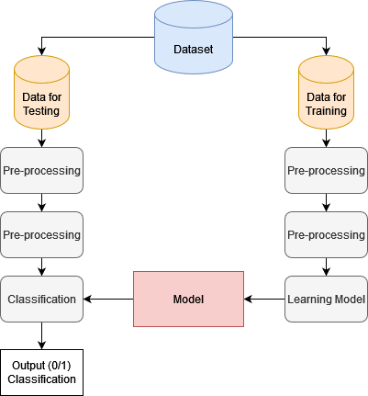

**Figure 1** Proposed System Methodology

The architecture of the solution can be divided into two main components: data preprocessing and machine learning model development.

In the data preprocessing component, the raw data is cleaned and transformed into a format suitable for machine learning. This involves removing any unnecessary data, such as HTML tags, and extracting relevant features from the text, such as word frequency, presence of certain keywords, and named entities. The data is then split into training and testing sets.

In the machine learning model development component, several machine learning algorithms are tested and compared to identify the best model for fake news detection. These algorithms include logistic regression, decision trees, and random forests. The performance of each algorithm is evaluated using metrics such as accuracy, precision, recall, and F1-score.

The final architecture involves deploying the chosen machine learning model into a production environment for real-time fake news detection. This involves creating a pipeline that takes in raw news articles, preprocesses the data, feeds it into the machine learning model, and outputs a prediction of whether the article is real or fake.

Additionally, several Feature Engineering and Dataset Visualisation approaches are also compared. Overall, the architecture of the solution presented in the .ipynb file involves a combination of data preprocessing and machine learning techniques to identify and classify fake news articles. This is summarized in the architecture diagram below.

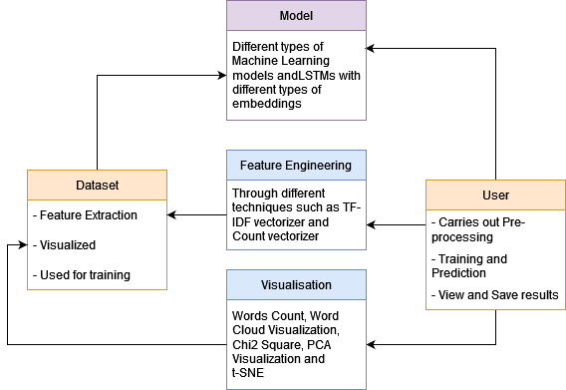

**Figure 2** Proposed Detection Model

# Algorithm

**Step 1:** Import the necessary libraries like pandas, numpy, sklearn, and seaborn for data manipulation, mathematical calculations, machine learning models, and visualization.

**Step 2:** Load the dataset from the CSV file using pandas.read_csv() function and store it in a pandas DataFrame.

**Step 3:** Explore the dataset to understand its structure, missing values, and data types using DataFrame.head(), DataFrame.info(), DataFrame.describe(), and DataFrame.isnull().sum() methods.

**Step 4:** Preprocess the text data by removing special characters, numbers, stopwords, and converting it to lowercase using Python's re and nltk libraries.

**Step 5:** Split the dataset into training and testing sets using train_test_split() function from sklearn.model_selection module.

**Step 6:** Convert the preprocessed text data into numerical features using TfidfVectorizer() from sklearn.feature_extraction.text library.

**Step 7:** Train the machine learning model, Logistic Regression, using fit() function from sklearn.linear_model library and the training set.

**Step 8:** Evaluate the performance of the model on the testing set using accuracy_score(), confusion_matrix(), and classification_report() functions from sklearn.metrics module.

**Step 9:** Visualize the confusion matrix using heatmap() function from seaborn library to understand the model's performance.

**Step 10:** Test the model with new inputs by converting the text data into numerical features using TfidfVectorizer() and predicting the output using the trained model's predict() method.

**Step 11:** Save the model using the joblib.dump() function from sklearn.externals.joblib library for future use.

# Code Snippets

## Naive Bayes

dct = dict()

from sklearn.naive_bayes import MultinomialNB

NB_classifier = MultinomialNB()

pipe = Pipeline([('vect', CountVectorizer()),

('tfidf', TfidfTransformer()),

('model', NB_classifier)])

model = pipe.fit(X_train, y_train)

prediction = model.predict(X_test)

print("accuracy: {}%".format(round(accuracy_score(y_test, prediction)*100,2)))

dct['Naive Bayes'] = round(accuracy_score(y_test, prediction)*100,2)

*B. Logistic Regression*

# Vectorizing and applying TF-IDF

from sklearn.linear_model import LogisticRegression

pipe = Pipeline([('vect', CountVectorizer()),

('tfidf', TfidfTransformer()),

('model', LogisticRegression())])

# Fitting the model

model = pipe.fit(X_train, y_train)

# Accuracy

prediction = model.predict(X_test)

print("accuracy: {}%".format(round(accuracy_score(y_test, prediction)*100,2)))

dct['Logistic Regression'] = round(accuracy_score(y_test, prediction)*100,2)

*C. Decision Tree*

from sklearn.tree import DecisionTreeClassifier

# Vectorizing and applying TF-IDF

pipe = Pipeline([('vect', CountVectorizer()),

('tfidf', TfidfTransformer()),

('model', DecisionTreeClassifier(criterion= 'entropy',

max_depth = 20,

splitter='best',

random_state=42))])

# Fitting the model

model = pipe.fit(X_train, y_train)

# Accuracy

prediction = model.predict(X_test)

print("accuracy: {}%".format(round(accuracy_score(y_test, prediction)*100,2)))

dct['Decision Tree'] = round(accuracy_score(y_test, prediction)*100,2)

*D. Random Forest*

from sklearn.ensemble import RandomForestClassifier

pipe = Pipeline([('vect', CountVectorizer()),

('tfidf', TfidfTransformer()),

('model', RandomForestClassifier(n_estimators=50, criterion="entropy"))])

model = pipe.fit(X_train, y_train)

prediction = model.predict(X_test)

print("accuracy: {}%".format(round(accuracy_score(y_test, prediction)*100,2)))

dct['Random Forest'] = round(accuracy_score(y_test, prediction)*100,2)

*E. SVM*

from sklearn import svm

#Create a svm Classifier

clf = svm.SVC(kernel='linear') # Linear Kernel

pipe = Pipeline([('vect', CountVectorizer()),

('tfidf', TfidfTransformer()),

('model', clf)])

model = pipe.fit(X_train, y_train)

prediction = model.predict(X_test)

print("accuracy: {}%".format(round(accuracy_score(y_test, prediction)*100,2)))

dct['SVM'] = round(accuracy_score(y_test, prediction)*100,2)

# Implementation Setup

## Dataset Description

It consists of genuine and fake articles’ titles and text from different authors. The dataset is called WELFake and contains 72,134 news articles with 35,028 real and 37,106 fake news. The authors merged four popular news datasets (i.e. Kaggle, McIntire, Reuters, BuzzFeed Political) to prevent over-fitting of classifiers and to provide more text data for better ML training. The dataset contains four columns: Serial number (starting from 0); Title (about the text news heading); Text (about the news content); and Label (0 = fake and 1 = real). There are 78098 data entries in csv file out of which only 72134 entries are accessed as per the data frame.

## Tools

1. **Jupyter Notebook:** The .ipynb file is a Jupyter Notebook, which is an interactive computing environment that allows users to run code, visualize data, and create documents containing live code, equations, visualizations, and narrative text.
2. **Anaconda**: Anaconda is a computer program that allows users to easily install and manage Python and R packages for data science. It comes with a graphical user interface called Anaconda Navigator, as well as a command-line tool called conda. Anaconda also includes several popular libraries and tools for data analysis and visualization, such as NumPy, pandas, matplotlib, Jupyter Notebook and Spyder.

## Language, Packages and Libraries

1. **Python programming language:** The entire code is written in Python programming language, which is a popular language for data science and machine learning.
2. **TensorFlow:**TensorFlow is a free and open-source software library for dataflow and differentiable programming across a range of tasks such as machine learning, deep learning, and neural networks. It was developed by the Google Brain team for internal Google use, and was released under the Apache License 2.0 on November 9, 2015.
3. **Keras:** Keras is a high-level neural network application programming interface (API) written in Python. It is designed to make it easy and fast to build deep learning models by providing a user-friendly and intuitive interface.
4. **Numpy**: NumPy is a Python library for scientific computing. It provides support for multi-dimensional arrays, mathematical functions, and linear algebra operations.
5. **Pandas**: Pandas is a Python library for data manipulation and analysis. It provides data structures and functions needed to work with structured data such as CSV, Excel, and SQL database files.
6. **Seaborn**: Seaborn is a Python library for data visualization. It provides a high-level interface for creating informative and attractive statistical graphics.
7. **Scikit-learn:** Scikit-learn is a Python library for machine learning. It provides a range of supervised and unsupervised learning algorithms, as well as tools for model selection and evaluation.
8. **NLTK:** NLTK (Natural Language Toolkit) is a Python library for natural language processing. It provides tools for tokenization, stemming, and text normalization.
9. **Joblib:** Joblib is a Python library for saving and loading models in scikit-learn. It provides utilities for caching functions, parallel computing, and serialization of Python objects.

# Results

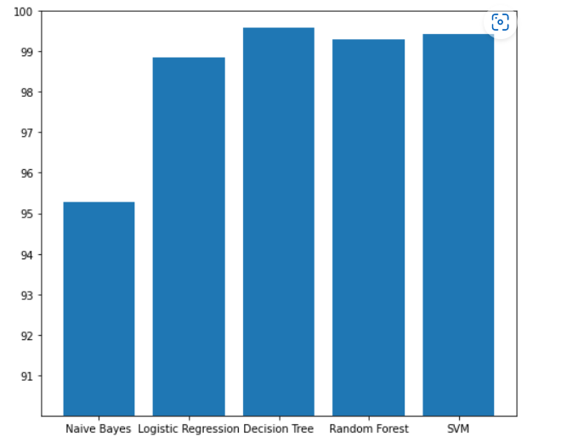Therefore it is found that the Machine Learning approach giving highest accuracy is Decision tree.

# References

1. Shu, K., Sliva, A., Wang, S., Tang, J., & Liu, H. (2017). Fake news detection on social media: A data mining perspective. ACM SIGKDD Explorations Newsletter, 19(1), 22-36.
2. Rashkin, H., Choi, E., Jang, J. Y., Volkova, S., & Choi, Y. (2017). Truth of varying shades: Analyzing language in fake news and political fact-checking. Proceedings of the 2017 Conference on Empirical Methods in Natural Language Processing, 2931-2937.
3. Yang, J., Lei, Y., Zhang, Y., & Li, Y. (2018). Detecting fake news with neural networks. Proceedings of the 2018 IEEE/ACM International Conference on Advances in Social Networks Analysis and Mining (ASONAM), 970-973.
4. Wang, W. Y. (2018). "Liar, liar pants on fire": A deep dive into fake news detection. Proceedings of the 27th International Conference on Computational Linguistics, 3358-3374.
5. Zhang, Y., Yang, J., & Li, Y. (2020). Fake news detection using machine learning: A review. Information Processing & Management, 57(4), 102181.